YouSaveIt WEBSITE

Proposal Document



**­TEAM: EAGLE**  
**Cycle 1 - Version: V.1.1**

**Revision History**

|  |  |  |  |
| --- | --- | --- | --- |
| **Date** | **Version** | **Description** | **Custodian/Organization** |
| 13/08/2013 | 1.0 | Initial publication. | EAGLE TEAM |

###### Table of Contents

1. Introduction 2

1.1 Purpose 2

1.2 Definitions, acronyms, and abbreviations 2

1.3 Project scope 2

1.4 References 2

1.5 Intended Audience and Reading Suggestions 3

2. General Description 4

2.1 System Context Diagram 4

2.2 Product functions 4

2.2.1. Function’s priorities 4

2.2.2. Function list 5

2.3 User characteristics 5

2.4 Operating environment 6

3. Use case diagram 7

4. Use case specification 9

4.1 Use case list 9

4.2 Use case detail 9

4.2.1. Use case Register 9

4.2.2. Use case Login 11

4.2.3. Use case Logout 12

4.2.4. Use case Add post 13

4.2.5. Use case Edit post 15

4.2.6. Use case Delete post 16

4.2.7. Use case Search 17

4.2.8. Use case View detail 18

Appendix A: Approval 21

# Introduction

## Purpose

The software requirements specification document describes the essential behavior of a system from a user's point of view. The complete description of the functions to be performed, provide a basis for developing the system design

Additionally this document describes the non-functional requirement, constraints, and other factors necessary to provide a complete, comprehensive description of the system requirement.

A complete and correct SRS reduces effort wasted on redesign, recoding and retesting.

## Definitions, acronyms, and abbreviations

|  |  |  |
| --- | --- | --- |
| **No.** | **Acronyms** | **Definitions** |
| 1 | RAD | Requirement Analysis Document |
| 2 | RED | Requirement Elicitation Document |
| 3 | SRS | Software Requirement Specification |
| 4 | IEEE | Institute of Electrical and Electronics Engineers |

## Project scope

This project builds a website that its purpose is to swap the item between the members. Developing the functions module topic, search function, register function, login/logout, send swap request function, consignment module, and admin control panel, evaluate user account, user control panel.

## References

* IEEE STD 830 - 1998 I EEE Recommended Practice for Software Requirements Specifications. IEEE Computer Society, 1998

## Intended Audience and Reading Suggestions

**The second part**, the Overall Description section, this part gives an overview of the functionality of the product. It describes the informal requirements and is used to establish a context for the technical requirements specification in the next part.

**The third part**, Requirements Specification section, this document is written primarily for the developers and describes in technical terms the details of the functionality of the product.

**The next part**, analysis model will allow understand detailed function. How to it implement in this system.

All sections of the document describe the same system in its entirety, but are intended for different audiences and thus use different language.

# General Description

## System Context Diagram

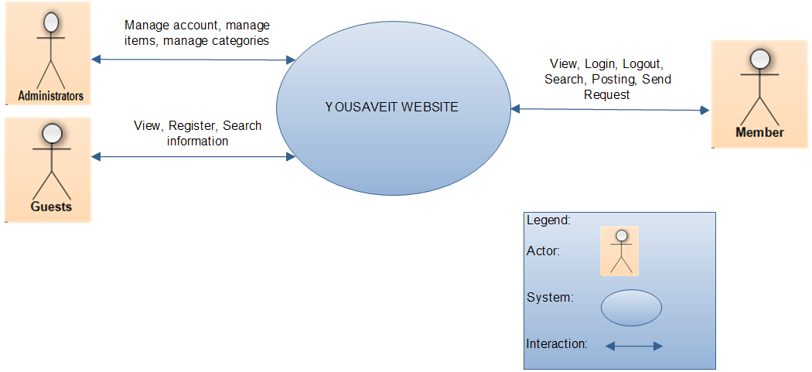

*Figure 1: System context diagram*

## Product functions

### Function’s priorities

Below is a list of all functions that can be found in the system with a description of the function and its priority. The priorities range from 1 to 3 with 1 being the highest priority and 3 being the lowest.

*Table 1: Function’s priorities range*

|  |  |
| --- | --- |
| **Priority** | **Detail** |
| 1 | Must have |
| 2 | Should |
| 3 | Nice to have |

### Function list

*Table 2: Function list*

|  |  |  |  |
| --- | --- | --- | --- |
| **ID** | **Name of Main Function** | **Description** | **Priority** |
| F01 | Register | This function is register to create a new account when they want to become a member uses the other functions of website by rules. | 1 |
| F02 | Login /Logout | This function is used for website’s member and administrator to login/logout to the system. | 1 |
| F03 | Posting management | This function is to give information about the items that they want to exchange. | 1 |
| F04 | Search | This function allows the user to search by category | 2 |

## User characteristics

*Table 3: The following is a list of the actors in the system and their description.*

|  |  |
| --- | --- |
| **Actors** | **Descriptions** |
| Administrators | Manage the whole system, grant permission, confirm, and update the information. |
| Member | Who registered account; this person has the right to use the post function, comment function. |
| Guest | Who can visit the website, search information |

## Operating environment

*Table 4: Operating environment*

|  |  |  |  |
| --- | --- | --- | --- |
| **Operating System** | **Feature** | **Minimum Required** | **Recommended** |
| Hardware | CPU | 1x Intel® Xeon® Sandy  Bridge Quad-Core E3-1220  2.20GHz 8MB 1GB RAM | Configurable: 1x Intel®  Xeon® Westmere Quad  Core Processor E5620,  3.40GHz, 12M  Configurable 4GB RAM |
| Software | Browser | Google Chrome | Firefox, Internet Explorer |
| OS | CentOS 32bit | Recommended: CentOS  64bit  Optional: Ubuntu,  Debian, Fedora (32bit or  64bit) |
| Hosting | Bandwidth | 300GB/month | Expandable 1TB/month |
| PHP | Version 5.1 |  |
| MySQL |  |  |
| PHPMyadmin |  |  |
| Apache |  |  |

# Use case diagram

*Table 5: Legend of use case diagram*

|  |  |  |
| --- | --- | --- |
| **Construct** | **Description** | **Syntax** |
| Use case | A sequence of actions, including variants, that a system (or other entity) can perform, interacting with actors of the system. |  |
| Actor | A coherent set of roles that users of use cases play when interacting with these use cases. |  |
| System boundary | Represents the boundary between the physical system and the actors who interact with the physical system. |  |
| Relationship | Relationship between use case |  |

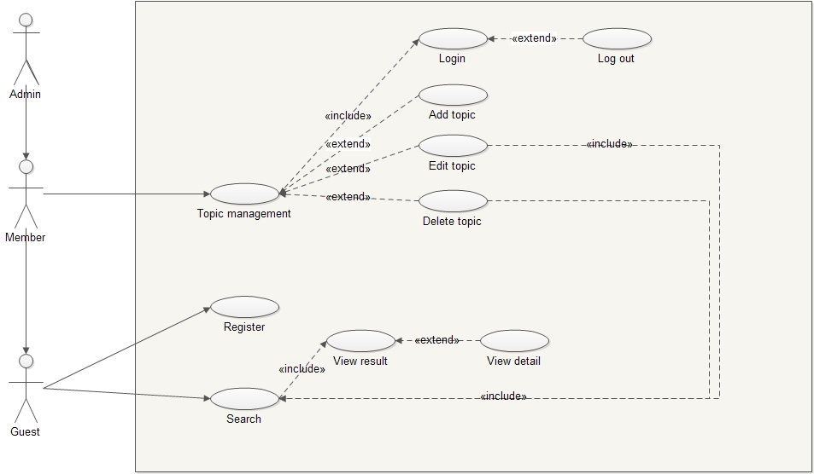

*Figure 2: Use case overview*

# Use case specification

## Use case list

|  |  |  |
| --- | --- | --- |
| **Use case ID** | **Use case name** | **Note** |
| UC01 | Register |  |
| UC02 | Login |  |
| UC03 | Logout |  |
| UC04 | Add post |  |
| UC05 | Edit Post |  |
| UC06 | Delete post |  |
| UC07 | Search |  |
| UC08 | View detail |  |

## Use case detail

### Use case Register

*Table 7: Use case Register detail*

|  |  |  |  |  |
| --- | --- | --- | --- | --- |
| Use Case ID | UC01 | | | |
| Use Case Name | Register | | | |
| Create by | Phuong Trinh | | Last Updated By | Phuong Trinh |
| Date Created | 30/9/2013 | | Date Last Updated | 30/9/2013 |
| Actor | Guest | | | |
| Description | This function is used to the actors register an account, it help they can use the others function of website. | | | |
| Trigger | 1. Register | | | |
| Precondition | 1. No account used in the system. | | | |
| Post condition | 1. User’s Information is added in Database 2. User can use the others function of the system by rules | | | |
| Normal flow | Register | | | |
| Step | Description | | |
| 1 | Navigate website | | |
| 2 | Click on Button “Register” | | |
| 3 | Register form is shown and User enters valid and full information. | | |
| 4 | Message box notify success register and click button “OK” | | |
| 5 | System direct to Home page | | |
| 6 | The end | | |
| Alternative Flow | N/A | | | |
| Exceptions | Case 1: The email has been used. The system will display the message “This email is existed, please choose another one”.  Case 2: Enter email incorrect. The system will display the message  “Please enter an email address”. | | | |
| Includes | N/A | | | |
| Extend | N/A | | | |

### Use case Login

Table 8: Use case Login detail

|  |  |  |  |  |
| --- | --- | --- | --- | --- |
| Use Case ID | UC02 | | | |
| Use Case Name | Login | | | |
| Create by | Phuong Trinh | | Last Updated By | Phuong Trinh |
| Date Created | 30/9/2013 | | Date Last Updated | 30/9/2013 |
| Actor | Administrator  Member | | | |
| Description | This function is used to the actors login an account into the system, it help they can use the others function of website. | | | |
| Trigger | 1. Login | | | |
| Precondition | Having an account exist in the system. | | | |
| Post condition | The system must direct to home page. | | | |
| Normal flow | Login | | | |
| Step | Description | | |
| 1 | Navigate website | | |
| 2 | Click on “Login” | | |
| 3 | Login form is shown and User enters username and password | | |
| 4 | Click on Button “Login” | | |
| 5 | System will display message: “Login successfully” and direct to homepage” | | |
| 6 | The end | | |
| Alternative Flow | N/A | | | |
| Exceptions | Data entry:   * Users enter wrong user name or password * Users enter wrong format | | | |
| Includes | N/A | | | |
| Special Requirement | To ensure the safety of the system, each actor is entitled to re-enter your user email and password (if the error log) maximum 3 times. Then the system will automatically use case ends. | | | |
| Extend | N/A | | | |

### Use case Logout

*Table 9: Use case Logout detail*

|  |  |  |  |  |
| --- | --- | --- | --- | --- |
| Use Case ID | UC03 | | | |
| Use Case Name | Logout | | | |
| Create by | Phuong Trinh | | Last Updated By | Phuong Trinh |
| Date Created | 30/9/2013 | | Date Last Updated | 30/9/2013 |
| Actor | Administrator  Member | | | |
| Description | This function is used to exit the system. | | | |
| Trigger | 1. Log out | | | |
| Precondition | The user had to log into the system with a defined role | | | |
| Post condition | If Use case is successful, the user now has escaped the system and the system prevents any further access that it need requests login from users. | | | |
| Normal flow | Step | Description | | |
| 1 | User click on “Logout” | | |
| 2 | The system requires users to confirm the logout | | |
| 3 | The system return to the main interface | | |
| 4 | The end | | |
| Alternative Flow | N/A | | | |
| Exceptions | N/A | | | |
| Includes | UC02 | | | |
| Extend | After a period the user is not interacting with the system, the system will automatically save their work (if any) and the user logged out. | | | |

### Use case Add post

|  |  |  |  |  |
| --- | --- | --- | --- | --- |
| Use Case ID | UC04 | | | |
| Use Case Name | Add Post | | | |
| Create by | Phuong Trinh | | Last Updated By | Phuong Trinh |
| Date Created | 30/10/2013 | | Date Last Updated | 30/10/2013 |
| Actor | Administrator  Member | | | |
| Description | This function is used to add new information about an item. | | | |
| Trigger | 1. Post | | | |
| Precondition | User had an account on the system. | | | |
| Post condition | The new information must be shown in the website and database must be updated. | | | |
| Normal flow | Step | Description | | |
| 1 | At home page, Click navigation, choose Control panel | | |
| 2 | Click button “New Topic” | | |
| 3 | A form is shown, user fill in full information  Category  Item’s name  Description  Choose picture from computer  Check allow listing or not | | |
| 3 | Click on “Create” | | |
| 4 | The website display message “You posted successfully” | | |
| 5 | The end | | |
| Alternative Flow | N/A | | | |
| Exceptions | Data entry   * Users isn’t fill all of required field | | | |
| Includes | UC02 | | | |
| Extend | N/A | | | |

### Use case Edit post

|  |  |  |  |  |
| --- | --- | --- | --- | --- |
| Use Case ID | UC05 | | | |
| Use Case Name | Edit Post | | | |
| Create by | Phuong Trinh | | Last Updated By | Phuong Trinh |
| Date Created | 30/10/2013 | | Date Last Updated | 30/10/2013 |
| Actor | Administrator  Member | | | |
| Description | This function is used to edit the contents of the post | | | |
| Trigger | 1. Edit post | | | |
| Precondition | User had an account on the system.  A post existed in system | | | |
| Post condition | Information will be change | | | |
| Normal flow | Step | Description | | |
| 1 | User click “control panel” on navigation | | |
| 2 | Find post want to edit | | |
| 3 | User edit content of this topic | | |
| 4 | User submit | | |
| 5 | The end | | |
| Alternative Flow | 1 | User click topic on the Home page | | |
| 2 | User click Edit | | |
| 3 | User edit content of this topic | | |
| 4 | User submit | | |
| Exceptions | N/A | | | |
| Includes | UC02 | | | |
| Extend | N/A | | | |

### Use case Delete post

|  |  |  |  |  |
| --- | --- | --- | --- | --- |
| Use Case ID | UC06 | | | |
| Use Case Name | Delete Post | | | |
| Create by | Phuong Trinh | | Last Updated By | Phuong Trinh |
| Date Created | 30/10/2013 | | Date Last Updated | 30/10/2013 |
| Actor | Administrator  Member | | | |
| Description | This function is used to delete the post available on the system (Member is deleted themselves). | | | |
| Trigger | 1. User delete the post | | | |
| Precondition | Must have an account in system.  A post existed in the system | | | |
| Post condition | That post will not exist on website | | | |
| Normal flow | Step | Description | | |
| 1 | User click “control panel” on navigation | | |
| 2 | User find post want to delete | | |
| 3 | User click button delete | | |
| 4 | The end | | |
| Alternative Flow | 1 | User click on their own topic | | |
| 2 | User click button “Remove” | | |
| 3 | User submit | | |
| 4 | The end | | |
| Exceptions | N/A | | | |
| Includes | UC02 | | | |
| Extend | N/A | | | |

### Use case Search

|  |  |  |  |  |
| --- | --- | --- | --- | --- |
| Use Case ID | UC07 | | | |
| Use Case Name | Advance Search | | | |
| Create by | Phuong Trinh | | Last Updated By | Phuong Trinh |
| Date Created | 30/10/2013 | | Date Last Updated | 30/10/2013 |
| Actor | Administrator  Member  Guest | | | |
| Description | The function is used to search topic in website | | | |
| Trigger | 1. Search | | | |
| Precondition | N/A | | | |
| Post condition | Display search result | | | |
| Normal flow | Step | Description | | |
| 1 | At home page website, user click on “Search” on navigation | | |
| 2 | User enter keyword | | |
| 3 | User click on “Search” | | |
| 4 | The result is display | | |
| 5 | The end | | |
| Alternative Flow | N/A | | | |
| Exceptions | 1. Keyword don’t match database | | | |
| Includes | N/A | | | |
| Extend | N/A | | | |

### Use case View detail

|  |  |  |  |  |
| --- | --- | --- | --- | --- |
| Use Case ID | UC08 | | | |
| Use Case Name | View detail | | | |
| Create by | Phuong Trinh | | Last Updated By | Phuong Trinh |
| Date Created | 30/10/2013 | | Date Last Updated | 30/10/2013 |
| Actor | Administrator  Member  Guest | | | |
| Description | The function is used to search topic in website | | | |
| Trigger | 1. View detail | | | |
| Precondition | N/A | | | |
| Post condition | Display topic detail | | | |
| Normal flow | Step | Description | | |
| 1 | At home page website, click on title of topic | | |
| 2 | The result is display | | |
| 3 | The end | | |
| Alternative Flow | 1 | User enter keyword on search textbox | | |
| 2 | User click button search | | |
| 3 | Result is display | | |
| 4 | User click on title of topic | | |
| 5 | The detail of this topic will display | | |
| 6 | The end | | |
| Exceptions |  | | | |
| Includes | N/A | | | |
| Extend | N/A | | | |

# Appendix A: Approval

|  |  |  |
| --- | --- | --- |
| **Prepared by** | **Signature** | **Date** |
| Tran Cong Binh  K16CMU-TTT | | |
| **Approved by** | **Signature** | **Date** |
| Tran Kim Sanh  Mentor  Duy Tan University | | |
| Nguyen Trinh Trung Duong  Mentor  Duy Tan University | | |